**English Worksheet.**

**Unit I – The media and the message in today’s globalized world.**

**HABILIDADES – SKILLS:**

**- Leer textos y reconocer nuevo vocabulario en ambos idiomas.**

**\* Read the texts and recognize the new vocabulary in both languages.**

**- Leer textos, analizar información y desarrollar las actividades.**

**\* Read the texts, analyse the info and complete the activities.**

**STUDENT : _________________________________________________.**

**GRADE: 4TH GRADE ________ DATE: ____________________________.**

**MISTER JUAN CARLOS JARA R. Score: __________ Mark: ____________**

**Instrucciones – Instructions:**

**- Evite los borrones y el uso de corrector.**

**\* Avoid smudges or stains and the use of correction pen.**

**- Responda utilizando los espacios destinados dentro de la guía.**

**\* Use the suitable area to complete each activity.**

**- Utilice solo lápiz de pasta (azul/negro) o grafito.**

**\* Use pen (blue/black) o pencil.**

**1.- Reading Comprehension. Read the texts on the next page and recognize the new vocabulary. Complete the chart below.**

**2.- Reading Comprehension. Read the texts again and complete the activities.**

|  |  |  |  |
| --- | --- | --- | --- |
| **ENGLISH** | **SPANISH** | **ENGLISH** | **SPANISH** |
|  |  |  |  |
|  |  |  |  |
|  |  |  |  |
|  |  |  |  |
|  |  |  |  |
|  |  |  |  |
|  |  |  |  |
|  |  |  |  |



**1.- Answer the following questions. (8 points)**

**a**.- What is advertising?

__________________________________________________________________________________________________________________________________________________________________________________________________________________________________________________________________________________________________________________

**b**.- Why do we advertise?

___________________________________________________________________________________________________________________________________________________________________________________________________________________________________________________________________________________________________________________

**c.** Is advertising really necessary? Why?

__________________________________________________________________________________________________________________________________________________________________________________________________________________________________________________________________________________________________________________

**d.** What makes advertising catchy?

__________________________________________________________________________________________________________________________________________________________________________________________________________________________________________________________________________________________________________________

Advertising can be especially persuasive because of the combination of text and image. Illustrations and photographs help to engage the reader. The images might visually represent the text or be included to alter our perception of a particular topic. Just like written text, a picture can show something superficially **(denotation: the literal meaning; what you see)** but also something else beneath the surface **(connotation: the feelings, story or ideas the image evokes)**. Images add more meaning to a text; likewise, a well-chosen caption (text) can also add meaning and guide or influence the way in which the audience sees the image.

**Match the advertising terminology with correct LETTER. (16 pts)**

|  |  |
| --- | --- |
| 1.Audience _______ | a. A preconceived notion, especially about a group of people. |
| 2.Broadcast _______ | b. A set of opinions or beliefs of a group or an individual. |
| 3.Connotation _______ | c. what the word literally says. |
| 4.Denotation _______ | d. A specific type of music, film, or writing. |
| 5.Competitor _______ | e. Advertising that informs and educates rather than selling a product or service. |
| 6.Institution _______ | f. any interconnected system. |
| 7.Ideology _______ | g. Advertising that appears in movies or TV shows. |
| 8.Genre _______ | h. A type of advertising that appears in magazines, newspapers, brochures, leaflets. |
| 9.Network _______ | i. A type of advertising that appears on the internet. |
| 10.Stereotype _______ | j. the people, considered as a group, who watch or listen to a performance, movie, public event, etc., either together in one place or separately. |
| 11.Outdoor Advertising _______ | k. to air a program, especially on TV or radio. |
| 12.Public Service Advertising _______ | l. A type of advertising that appears in cell-phones. |
| 13.Product Placement Advertising _______ | m. It promotes products by showing them in original ways in the showcase of shops. |
| 14.Print Advertising _______ | o. The feeling a word invokes. |
| 15.Digital Advertising _______ | p. A big scale type of advertising that appears at bus stops or in roads and highways. |
| 16.Mobile Advertising _______ | q. rivals or contenders for the same thing. |

**EXTRA INFO:**

**Language techniques used in modern advertising:**

This pyramid which contains the essence of persuasive language used in any text type. Messages can appeal to only one of them, two or the three of them.

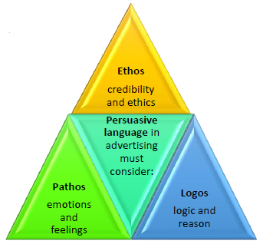

**Other elements that are used when creating effective, catchy adverts are:**

* **Concision and Straightforwardness**: Examples: 'We race, you win' (for an automobile); 'On time, every time' (express mail service); 'It's all within your reach'; 'Every time a good time' (restaurant). - Clarity: "Melts in your mouth, not in your hand." — M&M's; "Think outside the bun" — Taco Bell
* **Neologisms**: The invention of new words. Examples: Penguin Books “Unputdownable” Mercedes-Benz “Fabuttractive. The E-Class Coupé. It deserves a whole language”
* **Repetition**: “REUSE, REDUCE, RECYCLE or REGRET” I am proud of my people. I am proud of my heritage. I will voice my pride (US Census Bureau).
* **Promise function**: As long as the world is full of durable people, we'll keep making durable fabrics. (Cordura Fabric)

**Examples of slogans for social issues advertisements:**

* Travelling fruits cause pollution. Think global. Eat local (BUND / Friends of the Earth).
* How do you build a long-lasting relationship with a patient? You build a device that keeps them alive (Massachusetts General Hospital).
* For more information on lung cancer, keep smoking (The Lung Association, British Columbia).

A slogan is a creative phrase that summarizes the essence of a product, service or organization. Many slogans use rhetorical figures such as simile, metaphor, repetition, alliteration or onomatopoeia to make the audience remember the message.

|  |  |
| --- | --- |
| **Onomatopoeia**: words whose sounds show their meaning. | Splash! Pow! Punch! Gulp |
| **Repetition**: repetition of certain words for effect | I only want you to understand, I only want you to believe, I only want you to be free! |
| **Hyperbole**: Exaggeration | I almost died of the impression! This is the best ice cream in the world! |
| **Alliteration**: repetition of initial sounds | **K**it-**k**at, **m**isty **m**ountain, **f**orever **f**ree |
| **Simile**: Comparison of two things using “like” or “as” | My head is as round as the moon. |
| **Metaphor**: comparison in which something is said to be something else. | My head is the moon that watches you at night. |

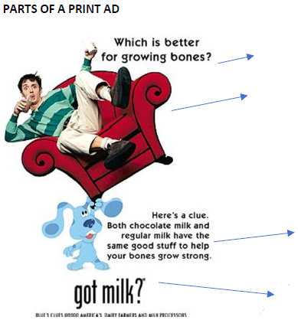

1. **SUB HEADLINE** Used to break up text. Larger than copy letters. Set in bold or italic.

2. **ILLUSTRATION** The photographs or drawing used in a print advertisement.

3. **COPY/BODY** The selling message in a written advertisement.

4. **SIGNATURE** The distinctive identification symbol and/or slogan for a business.